Butyl Bestarose HP
High-resolution hydrophobic chromatography resin

Instruction for Use

Bestchrom (Shanghai) Biosciences Ltd.
Contents
1. Introduction 1
2.Technical characteristics 1
3. Method of chromatographic 2
4. Application 5
5. Cleaning-in-place(CIP) 5
6. Sterilization 6
7. Storage 6
8. Disposal and Recycling 6
9. Order information 6

1. Introduction
Hydrophobic interaction chromatography (HIC) is a chromatographic method that uses the interaction between the hydrophobic groups carried by biological molecules and the hydrophobic ligands on the stationary phase to separate substances. Salt ions can destroy the hydration membrane on the surface of biomolecules and promote the binding between hydrophobic groups and ligands.
The framework of Butyl Bestarose HP hydrophobic resin is highly cross-linked agarose, which retains the excellent hydrophilicity and pore structure of natural polysaccharide compoundsand has good compatibility with biological macromolecules. The average particle size of Butyl Bestarose HP is 34μm, which has a higher resolution efficiency than Butyl Bestarose FF. The surface contains hydrophobic ligands, the ligand is butyl, which is particularly suitable for the fine separation and purification of recombinant proteins, antibodies, vaccines, VLP particles and other highly hydrophobic biological molecules.

2.Technical characteristics
Appearance | White slurry, can be layered
Matrix | Highly cross-linked agarose, 6%
Functional group | Butyl
Ligand concentration | ~50μmol Ligand/mL resin
Dynamic binding capacity | 38mg β-Lactoglobulin/mL packed resin
Particle size⁺ | 24~44μm(the average particle size is 34μm)
Max. pressure | 0.3 MPa
Pressure flow velocity | ≥200cm/h(0.1MPa BXK50/30 H=15cm 25℃)
Chemical stability | Stable in common aqueous buffers: 1M NaOH++、1M HAc++、6M GuHCl、30% isopropyl alcohol、70% ethanol
pH stability | 2~14(CIP),3~12(working)
Temperature tolerance | Working temperature: 2~40℃, Can't freeze, Can tolerate 121℃ high pressure sterilization (20min)
Storage+++ | 2~30℃, 20% ethanol or 2% benzyl alcohol
Recommended flow velocity | 60~120cm/h
+Particle size is normally distributed, and particles within this range account for more than 75% of the total.
++1M NaOH and 1M HAc only be used for cleaning.
+++ 2% benzyl alcohol is only used for international transport or special requirements from customer

3. Method of chromatographic
3.1 Column packing
Note：It is best to equilibrate the resin slurry to room temperature before column packing.
- According the column volume to calculate the amount of resin.
Resin volume=column volume×1.15(Compression factor=1.15)
According to the volume of the settlement resin required, the suspended slurry of the resin required is calculated by the follow:
Required resin slurry¹ volume = Settlement resin volume ÷ Resin slurry ¹ concentration. The original concentration of resin slurry ¹ is shown in the follow table.
Pack size | Resin slurry ¹ concentration (%)
25mL、100mL、500mL、1L、5L、10L | 80
20L、40L | 75
1: It refers to the original packaging resin slurry sold by Bestchrom.
Note: For non-original packaging, customer can calculate the required volume according to the actual concentration of resin slurry.
- Washing the resin: Suspend the resin by shaking and pour into a funnel, remove the liquid, and wash with about 3mL packing solution (20% ethanol)/mL resin for 3 times. Use a glass stick or stirrer to stir each time you add the packing solution, in order to better clean the shipping buffer.
- Prepare the packing slurry: Transfer the washed resin from the funnel into a beaker or other appropriate container, add packing solution to obtain a 50%~75% slurry, stir well and set aside for use.
- Take a cleaned BXK column (BXK series columns with diameters ranging from 1cm to 30cm can satisfy different scale chromatography applications). Take BXK16/20 for example, purge the bubbles trapped at the end-piece net by draining some packing solution through the column outlet. Leave about 1cm water at the bottom of the column and close the bottom outlet. Adjust the column so that it is perpendicular to the ground.
Description: Purification of biological macromolecules by hydrophobic resin is a typical highly selective technique, and the retention of substances to be separated may vary greatly at any particular ionic strength. Therefore, if you want to optimize the selectivity of using hydrophobic resin, you can use relatively short columns. Typical bed heights range from 3cm to 15cm to ensure high flow velocitys while avoiding excessive backpressure.
- Slowly pour the slurry into the column at one time (use a packing reservoir if necessary). Do not bring any air bubbles into the column.
Packing reservoir: Empty glasstube with same diameter as the BXK column.
- Fill the remainder of the column with packing solution. Connect the packing reservoir to the chromatography system, open the flow velocity, drain the bubbles in the hose, close the flow velocity, and tighten the top cover of the packing reservoir.
- After pouring, stir well again with stirrer, and then wash the resin particles on the inner wall of the column from top to bottom with the packing solution, and let the resin settle naturally until there is about 1cm of clarifying solution on the suspension. Mount the adapter and connect the adapter to the chromatography system or peristaltic pump. Lower the adapter to descend to contact with the clarifying solution and tighten the sealing ring after it is fully immersed in the clarifying solution. With the outlet of the top piece is opened, slowly move the adapter down until all bubbles are drained.
Note: This operation is only applicable to BXK 100 and above columns. Flushing the inner wall reduces the resin particles sticking between the seal ring and the column wall, avoiding the risk of leakage.
- When the bed height is 10cm, the flow velocity can be set to 30cm/h. Open the bottom plug, start the pump and run at the setting flow velocity until the bed is stabilized, then change pressure to constant 0.5MPa for column packing, mark the bed height.
- Remove the packing reservoir (if any), mount adaptor, lower the adaptor to about 0.5cm above the resin surface, keep pressing the column at 0.5MPa until the bed is completely consolidated, mark the consolidated bed height.
- Stop the pump, open top plug, close the bottom plug, loosen the O-ring seal slightly, press the adaptor to about 0.3cm below the marked position, tighten the O-ring seal, close adaptor stop plug, and complete the column packing.
3.2 Evaluation of Packing
- The packing quality of chromatographic column can be confirmed by column efficiency measurement and evaluation. The tests are required after the column packing, during the column working life and when the separation and purification performance weakens. The method usually relies on the height equivalent to a theoretical plate(HETP) and the asymmetry factor(As).
- Acetone or NaCl solution can be used as sample for the testing. Sample solution and mobile phase can be prepared according to the following table.
Acetone method NaCl method
Sample | 1.0%(v/v)acetone in water | 0.8M NaCl in water
Sample volume | 1.0%CV | 1.0%CV
Mobile phase | Water | 0.4M NaCl in water
Flow velocity | 30cm/h | 30cm/h
Monitor | UV280 nm | Conductivity
- Method for measuring HETP and As:
Use UV curve or the conductivity curve to calculate the height equivalent of theoretical plate (HETP), number of theoretical plates(N) and the asymmetry (As):

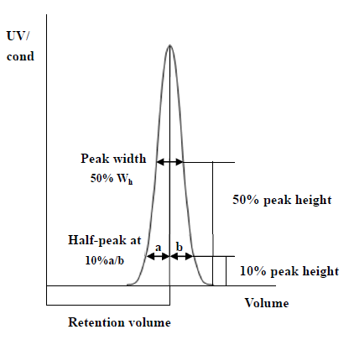
HETP=L/N
N=5.54(V_{R}/W_{h})²
Note: V_{R} = retention volume
W_{h} = half-peak width
L = column height
N = the number of theoretical plates
(The units of V_{R} and W_{h} should be the same)
As=b/a
Note:
a= 1st half peak width at 10% of peak height
b= 2nd half peak width at 10% of peak height
- Evaluation the column packing
As a guideline, if the value of HETP is less than 3 times the average particle size(d₅₀) of the resin and the As is between 0.8~1.8, the column is very efficient. The unsatisfactory results should be analyzed and the column should be repacked.
3.3 Chromatographic method
Note: The temperature has a greater influence on hydrophobic chromatography. Keeping the temperature of the environment, buffer and sample consistent during the experiment can ensure the repeatability of hydrophobic chromatography. It is generally controlled at 22~24℃.
- Buffer selection: The binding buffer is usually a phosphate buffer containing a high concentration of salt, such as 20mM PB, 1.5M (NH₄) ₂SO₄, pH 7.0. The elution buffer usually uses phosphate buffer without other salts, such as 50 mM PB, pH 7.0, which needs to be based on the subsequent experimental results (whether there is precipitation of the target, binding strength of the target, recovery rate, resolution etc.) Adjust the concentration and type of salt in the binding buffer. For substances that are difficult to elute, pure water can be used, or low-concentration ethanol can be added to the pure water as the eluent.
- Sample preparation: In order to prevent blocking of the column, the sample needs to be filtered by microporous membrane of 0.45μm before loading, the pH and conductivity of the sample are adjusted to be consistent with the equilibration buffer The loading volume is determined according to the impurity content in the sample and the combined loading of Butyl Bestarose HP
The binding strength of proteins to hydrophobic resin is affected by ligand structure, ligand concentration, ionic strength of buffer, salting out effect (see hofmeister sequence below), temperature, etc.
Hofmeister sequence:
- Salting out effect increases
negative ion：PO₄³⁻、SO₄²⁻、CH₃COO⁻、Cl⁻、Br⁻、NO₃⁻、ClO₄⁻、I⁻、SCN⁻
positive ion：NH₄⁺、Rb⁺、K⁺、Na⁺、Cs⁺、Li⁺、Mg²⁺、Ba²⁺
- The effect of salt solution increases
Increasing salting-out effect increases hydrophobic effect, while increasing salting-out effect weakens hydrophobic effect.
- Equilibration: Washing the column with equilibration buffer until the pH and conductivity of the column outlet buffer are basically the same as the equilibration buffer, which usually needs 3-5CV.
- Sampling: Sample loading shall be carried out according to the set conditions.
- Rinse: Rinse with equilibrium buffer until the UV absorption value drops to an appropriate value.
- Elution: A linear gradient or step gradient can be used to increase the elution intensity in the eluent, and substances with different binding strengths can be eluted from the chromatography column to collect different components and detect the location of the target.
- Regeneration: Flush the column with purified water or 30% isopropyl alcohol (70% ethanol).
- Rebalancing: After rinsing with equilibration buffer, the second sample can be loaded and repeated.

4. Application
Separation of cytochrome C, RNase, lysozyme, and α-Chymotrypsinogen using Butyl Bestarose HP

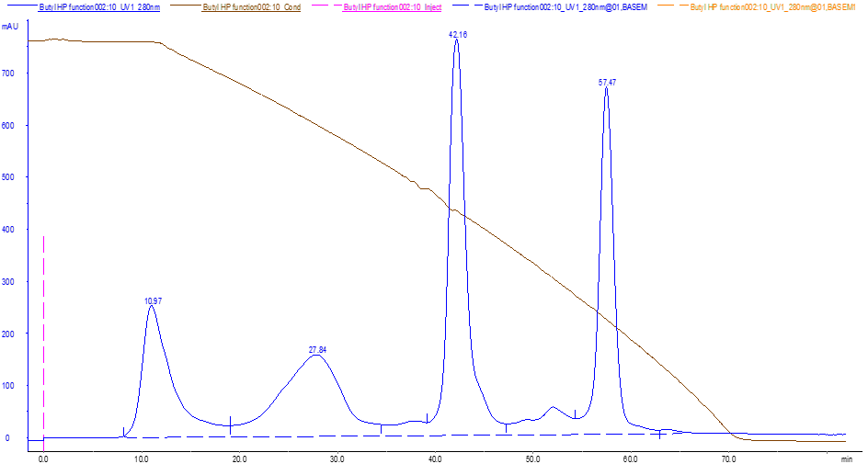
Column：BXR 10/17
Equilibration：20mM Tris 1.7M (NH₄)₂SO₄ pH 7.5
Elution：20mM Tris pH 7.5
Sample：Cytochrome C 1mg/mL
Lysozyme 1mg/mL
RNA enzyme 2mg/m
α-Chymotrypsinogen1mg/mL

5. Cleaning-in-place(CIP)
With the increasing use of chromatography resin, the accumulation of contaminants on the chromatography column is also increasing. Cleaning-in-place can prevent the accumulation of contaminants and maintain a stable working state. Determine the frequency of CIP according to the degree of contamination of the resin (if the contamination is serious, CIP should be carried out after each use to ensure repeatability of the results).
The recommended CIP for different types of impurities and contaminants are as follows:
- 2~3CV of purified water was used to wash out the proteins with relatively tight binding.
- Removal of strong hydrophobic proteins and precipitating proteins: Clean with 1M NaOH of 2~3CV first, then rinse immediately with 5~10CV pure water.
- Removal of lipoproteins and lipids: Clean with 70% ethanol or 30% isopropanol by volume of 5~10CV first, then rinse with pure water by volume of 5~10CV.
- The above two cleaning conditions can also be combined for cleaning, namely 30% isopropanol solution containing 1M NaOH.
Note: 70% ethanol or 30% isopropanol should be degassed before use. In the CIP process, the flow velocity can be chosen as 30~60cm/h. Reverse flushing can be used when the blockage is serious.
Laboratory type BXK small column polyacrylic plastic shell can not tolerate 70% ethanol and other high concentration of organic solvents, pay attention to the use of organic solvents do not spill on the plastic shell.

6. Sterilization
Since the 20% ethanol or 2% benzyl alcohol preservation solution does not have sterilization and depyrogenation, it is recommended that Butyl Bestarose HP can be treated with 1M NaOH for more than 0.5-1h to reduce the risk of microbial contamination before and during use. It can also be autoclaved at 121℃ for 20min.

7. Storage
Butyl Bestarose HP is supplied in 20% ethanol or 2% benzyl alcohol. It should be stored in 20% ethanol and sealed at 2-30℃ after use, in order to prevent ethanol volatilization and microbial growth, it is recommended to replace the storage solution every 3 months.

8. Disposal and Recycling
Butyl Bestarose HP is very difficult to degrade in nature, incineration is recommended to protect the environment.

9. Order information
Product | Code No. | Pack size
Butyl Bestarose HP | AH0071 | 25mL
 | AH203107 | 100mL
 | AH203111 | 500mL
 | AH0073 | 1L
 | AH0074 | 5L
 | AH203114 | 10L
 | AH203115 | 20L
 | AH203116 | 40L

Prepacked columns | Code No. | Pack size
EzFast Butyl HP | EH00721 | 1×1mL
 | EH103151 | 5×1mL
 | EH103103 | 1×5mL
 | EH103153 | 5×5mL
EzScreen Butyl HP | EH00725 | 1×4.9mL
 | EH00735 | 5×4.9mL
EzLoad 16/10 Butyl HP | EH00701 | 1 pcs
EzLoad 26/10 Butyl HP | EH00711 | 1 pcs

